# Meeting Information3446

|  |  |
| --- | --- |
| Meeting Name: | Information Modeling Project/FHIM Meeting |
| Date & Time: | February 12, 2016 2:30-4:00 PM ET |
| Location: | Online <https://global.gotomeeting.com/join/783145837> with VOIP or  **Dial** +1 (571) 317-3122, Access Code: 783-145-837 , **Password**: 3446  **Audio PIN**: Shown after joining the meeting, Meeting |

# 

# Attenance

| Name | Organization | Attendance |
| --- | --- | --- |
| Steve Wagner | FHA |  |
| Galen Mulrooney | FHA |  |
| Jay Lyle | FHA |  |
| Ioana Singureanu | VHA |  |
| Elisabeth (Liz) McCool | VHA |  |
| Raisa Ionin | DoD |  |
| Rob McClure | FHA |  |
| Scott Keller | CDC |  |
| David Bass | VHA | x |
| Stephen Hufnagel | FHA |  |
| Hamid Jalal | Organization unknown |  |
| Kenneth Salyards | SAMHSA |  |
| Robert Crawford | VHA |  |
| Iona Thraen |  |  |
| Susan Matney | 3M |  |
| Sean Muir | FHA |  |
| Bill Hess | FDA |  |
| Bo Wang | DHA |  |
| Will Hamilton | FHA |  |
| Loren Stevenson | VHA |  |
| John Weiser | DoD |  |
| Håkan Lidström | FHA |  |
| Tom Hokel | DoD |  |
| SGKeller |  |  |

# Summary

## Update on S&I and FHA Initiatives, Etc. (*Steve Wagner*)

No updates

## Terminology Modeling Update and Discussion (*Jay Lyle*)

Wednesday discussed care plan classification (e.g., condition, specialty, setting)

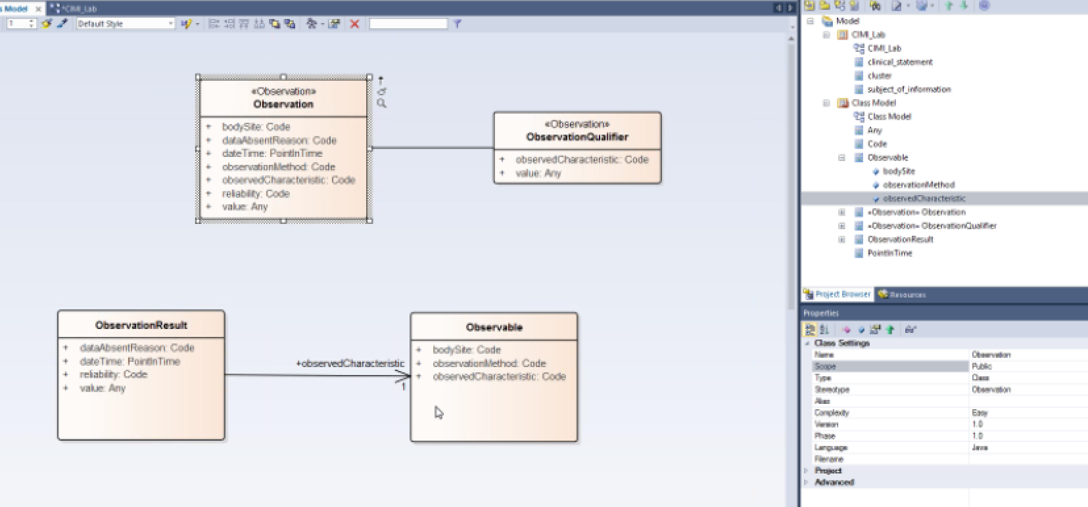

SNOMED LOINC RxNORM (SOLAR) with post-coordination separates observation class

Susan Matney: In US we use LOINC for observation

JayLyle: InterMountain has qualifier as abstract types.

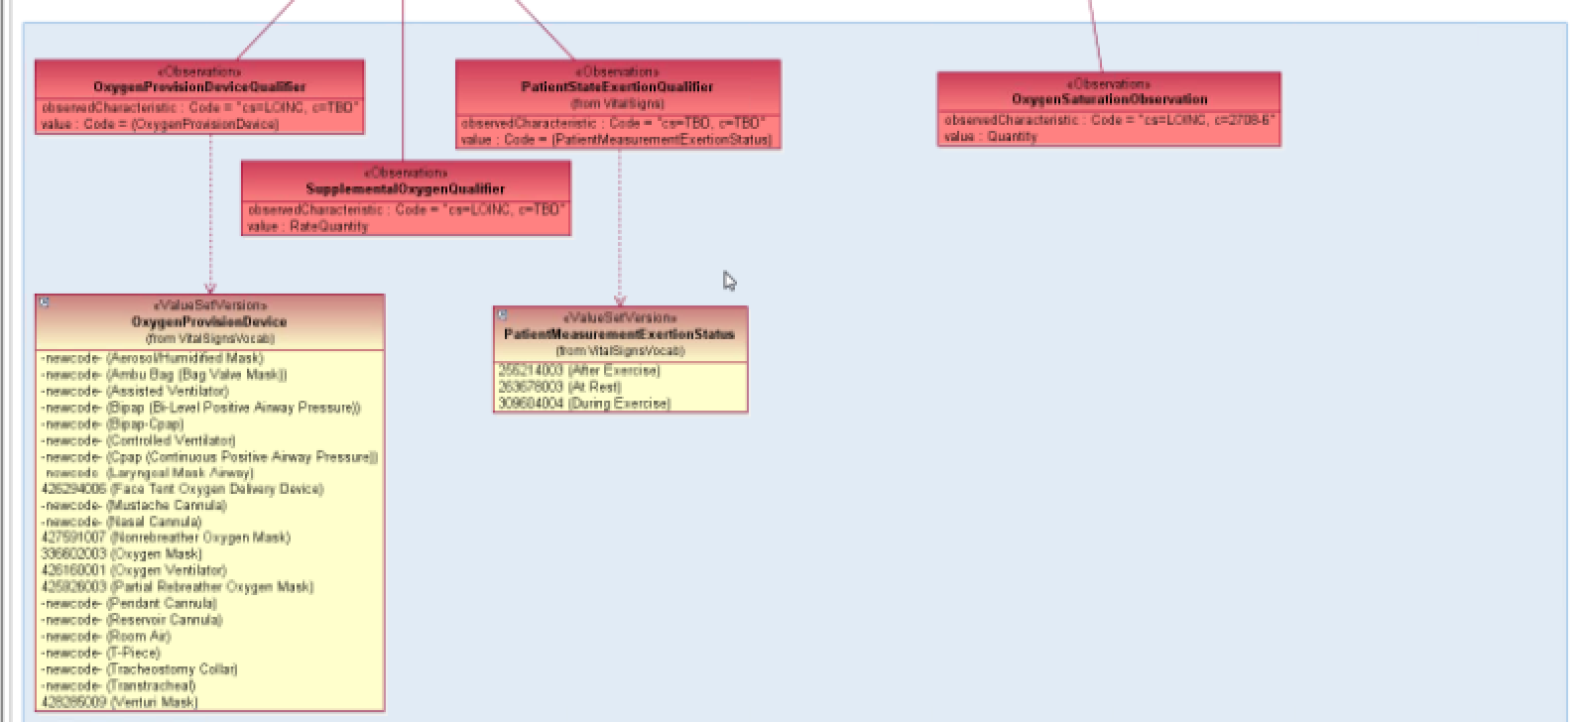

In some cases qualifier = method. At InterMountain Qualifier is an observation about a main observation

Tie attribute to a code

FHIM generate CIMI models.

Keith Campbell wants to design terminologies into the mosel.

Claude: The more expressive the logical model 🡪 the more difficult to transform to a physical model

Blood Pressure qualifiers:

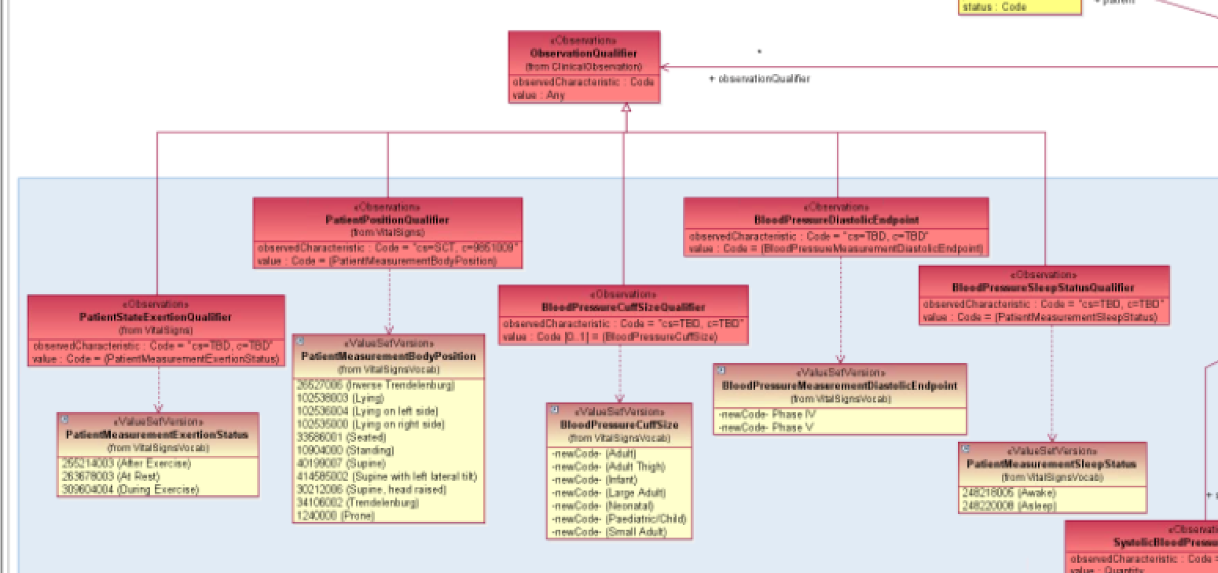

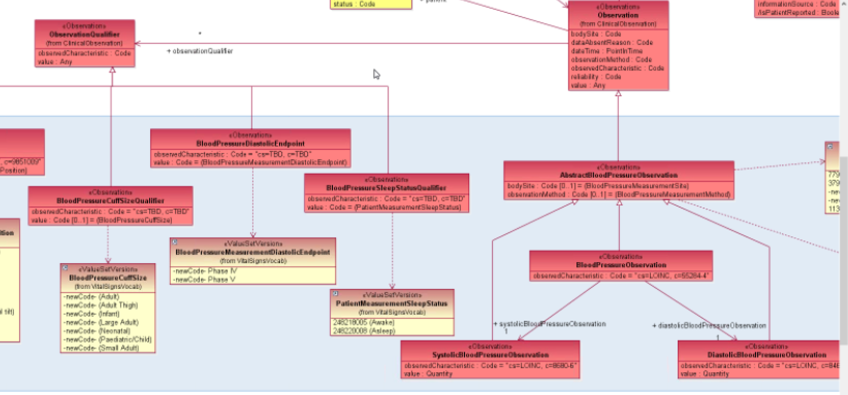

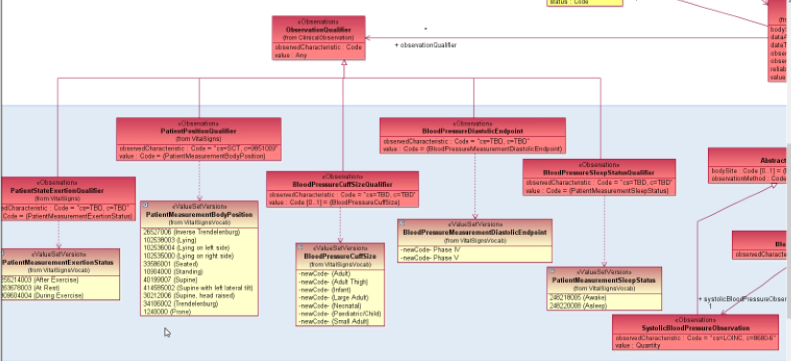

Claude: post coordinate in model or terminology. CIMI represents in the model & Keith puts representation in terminology. Give slots to commonly needed qualifiers. The base model does not have this, while, DCM has that.

Claude: logical model uses subtypes and Phusical model does name-vale pairs.

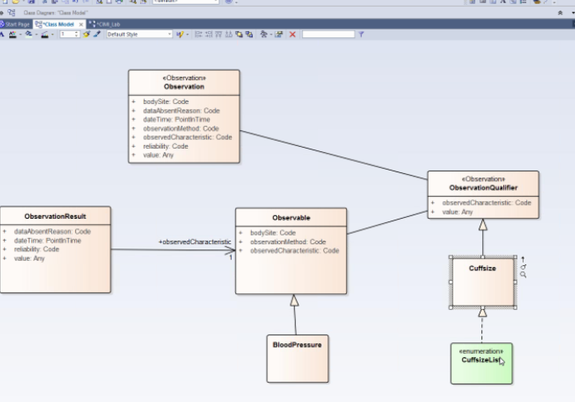

## Modeling the Clinical Decision Support Domain (*Galen Mulrooney*)

* Observation Class split into observable and results3446

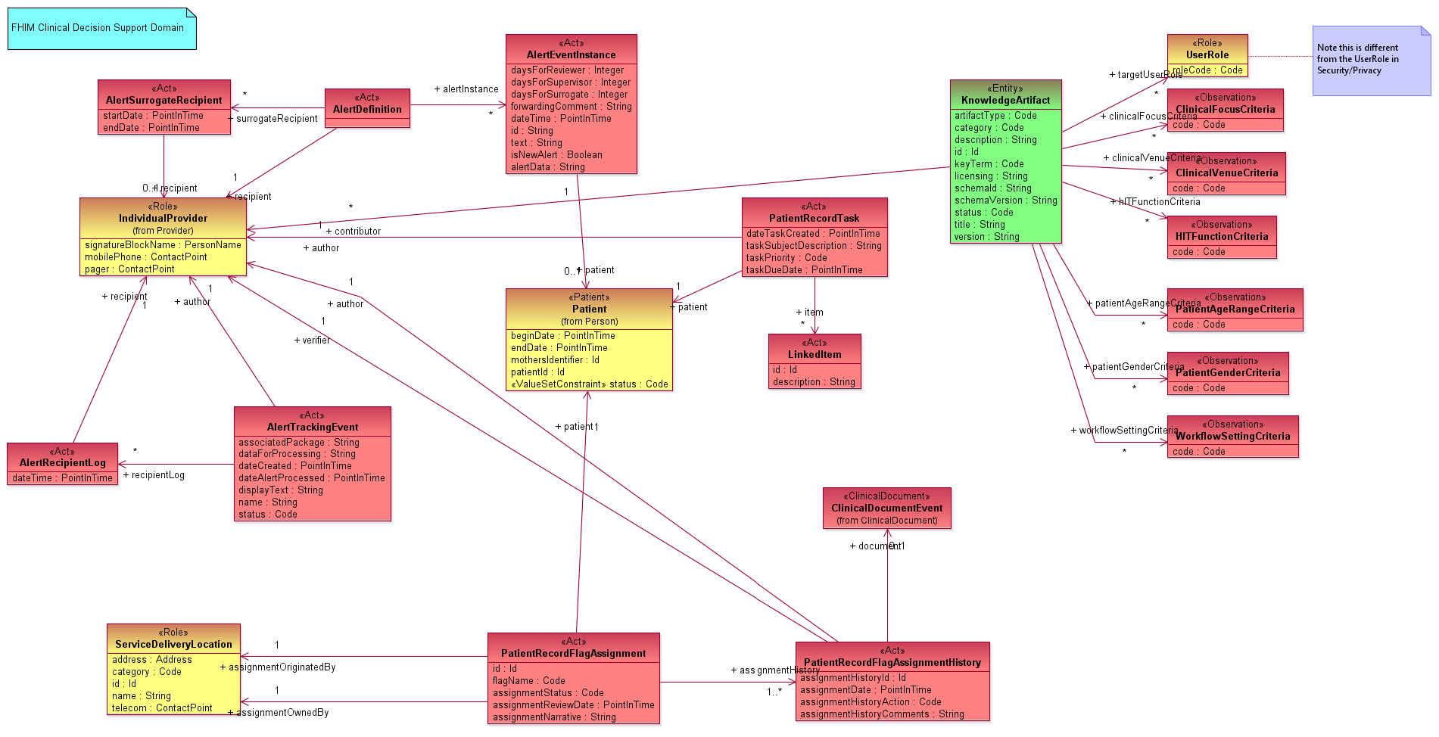

# Next Meeting

Friday, September 25, 2015 at 2:30 PM, EDT

# Action Items

| Action Item Description | Responsible | Due Date |
| --- | --- | --- |
| No new actions |  |  |
|  |  |  |

# FHIM Information and Terminology Modeling Calls

## Information Modeling (IM) project calls (Every Friday)

Time of Calls: 2:30 to 4:30 PM Eastern Time  
<https://global.gotomeeting.com/join/947006365>  
Use your microphone and speakers (VoIP) - a headset is recommended.  
Or, call in using your telephone.  
Dial +1 (646) 749-3131  
Access Code: 947-006-365  
Audio PIN: Shown after joining the meeting.

## Terminology Modeling calls (Every Wednesday)

Time of Calls: 2:00 to 3:30 PM Eastern Time  
<https://global.gotomeeting.com/join/947006365>  
Use your microphone and speakers (VoIP) - a headset is recommended.  
Or, call in using your telephone.  
Dial +1 (646) 749-3131  
Access Code: 947-006-365  
Audio PIN: Shown after joining the meeting.

## FHA Health Information Modeling WG (2’nd Tuesday each month)

Next meeting: at 1 PM Eastern Time

Time of Calls: 1:00 to 2:00 PM Eastern Time  
<https://www3.gotomeeting.com/register/267621646>

Use your telephone for audio.  
Dial + 1-888-537-7715 Code: 2734 4310#